CO–PO STUDENT ASSESSMENT REPORT | Student ID: 23-53049-3
INDIVIDUAL PROJECT ASSESSMENT | WEB TECHNOLOGIES
CO4 criteria, detailed components, and recorded student marks
Name | MD. MINHAZUL HASSAN | Student ID | 23-53049-3 | Group | 4 | Section AA
Git Repo | https://github.com/99Minhaz/summer-25-26-E-medicine-shop
CO4 ASSESSMENT
CO4: Coordinate with group members to develop multi-tier based web application
Technical Knowledge (0-3) |  |  |  | Collaborative Teamwork (0-3) |  | Communication/Promptness (0-3) |  | Total
JS validation | PHP Validation | Ajax/JSON | Marks  (0-3) | Git Contribution | Marks  (0-3) | VIVA | Marks  (0-3) | Total CO4 marks  (out of 9)
7 | 4 | 5 | 3.0 | TBD | 3.0 | TBD | TBD | TBD
Repository Evidence

Repository main page:
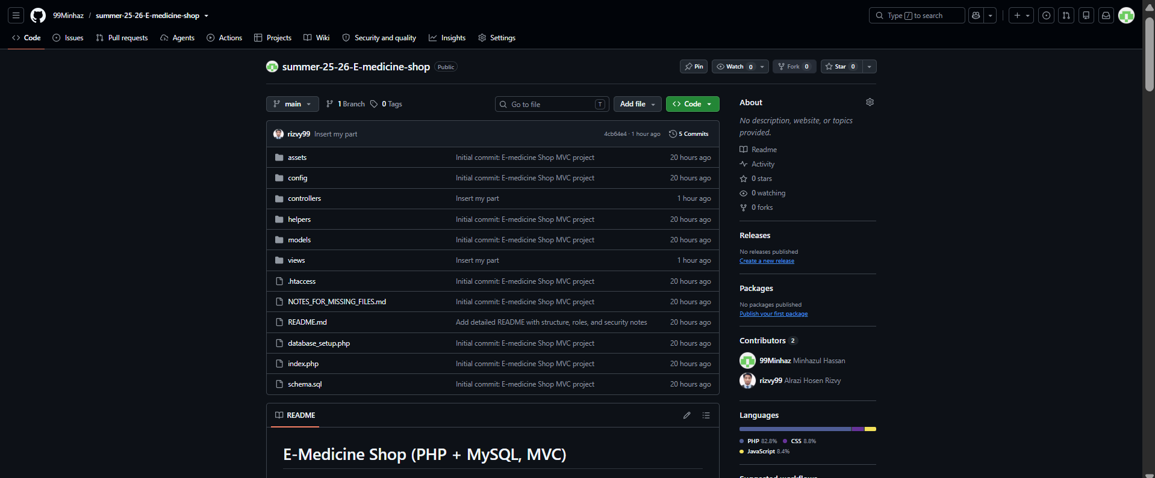

[Note: JS validation / PHP Validation / Ajax-JSON / Git Contribution raw counts, and the VIVA score, are left as TBD — fill these in from your own repo activity; VIVA is scored by the instructor on the day.]

